 | SIMATS ENGINEERING  Department of Computer Science and Engineering  CSA15 Cloud Computing and Big Data Analytics  CO2 AT2 - VM Configuration and Security Evidence Workbook  Guided practical workbook for Azure VM, local VM, Docker container, security checks, recovery evidence and GitHub submission
Assessment Metadata
Course Code | CSA15
Course Title | Cloud Computing and Big Data Analytics
Assessment | CO2 AT2 - VM Configuration and Security Evidence
Submission Type | Individual digital workbook based on the same capstone title used in CO1 and CO2 AT1
Faculty | Dr C. Rajesh Babu
Employee ID | SSETSCS415
Submission Mode | Completed workbook, evidence screenshots and GitHub repository link through Google Classroom
How This Workbook Works
- Use the same capstone title carried from CO1 and CO2 AT1.
- Read each procedure block, perform the action, verify the checkpoint and then fill the response table.
- Use Azure first when account activation is available. Use the local VM path when Azure is blocked. Use Docker for container comparison. Use simulation only when practical deployment is blocked.
- Screenshots must show the student's actual configuration or verified simulation work. Hide credentials, keys, tokens and sensitive account details.
- Upload the completed workbook and evidence to GitHub, then submit the GitHub repository link through Google Classroom.
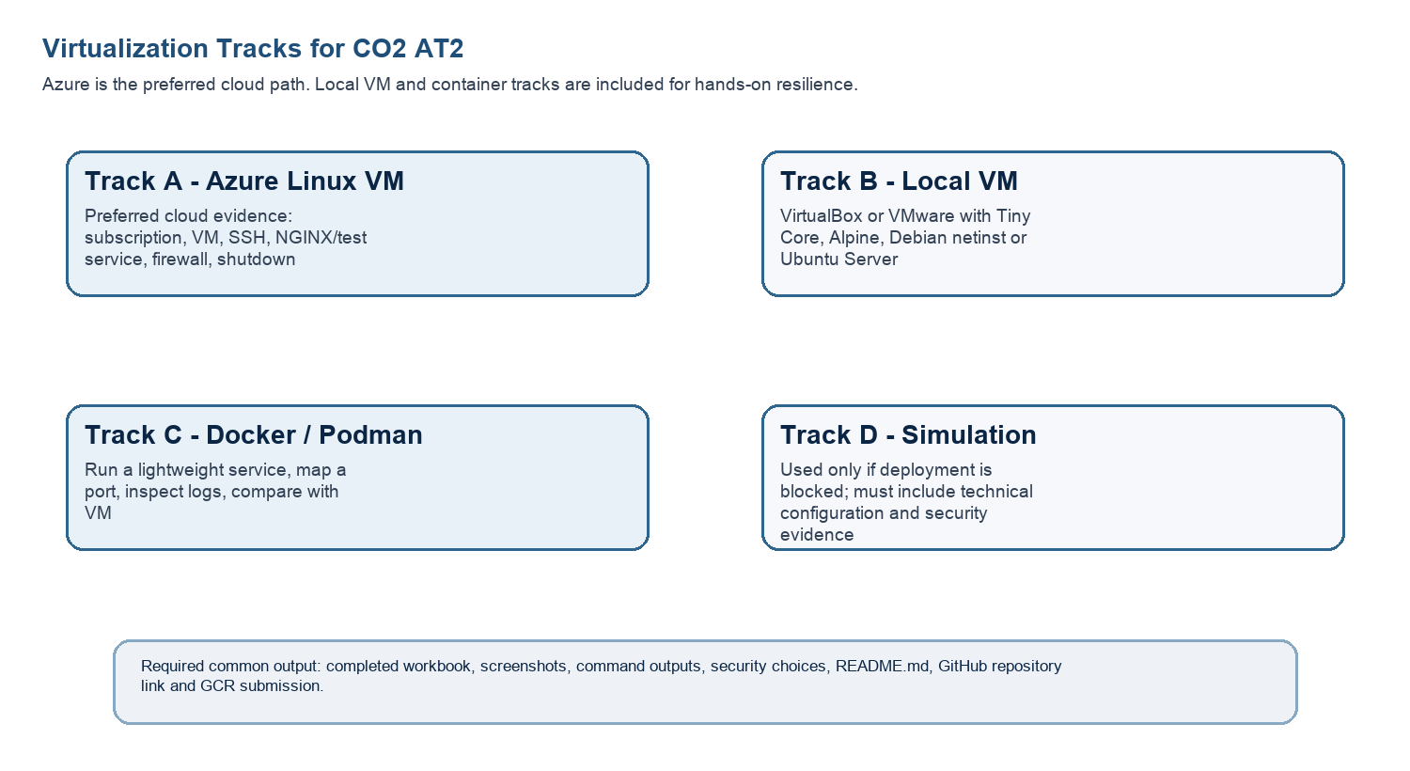
Technical Orientation
The practical work is not limited to clicking through screens. Each checkpoint requires observation: what appeared on screen, why it appeared, what it proves and how it connects to the capstone infrastructure plan.
Part 1: Student and Capstone Baseline
Student Name | P Rahul sai
Register Number | 192524226
Class / Slot | Slot B
Capstone Title | BloodBridge: Emergency Blood Donor Matching Application
CO2 AT1 Recommended VM Size | vCPU: __4__ RAM: __8GB__ Disk: __64GBSSD__
Selected Practical Track | Azure VM / Local VM / Docker / Simulation
GitHub Repository Link
Google Classroom Submission Date
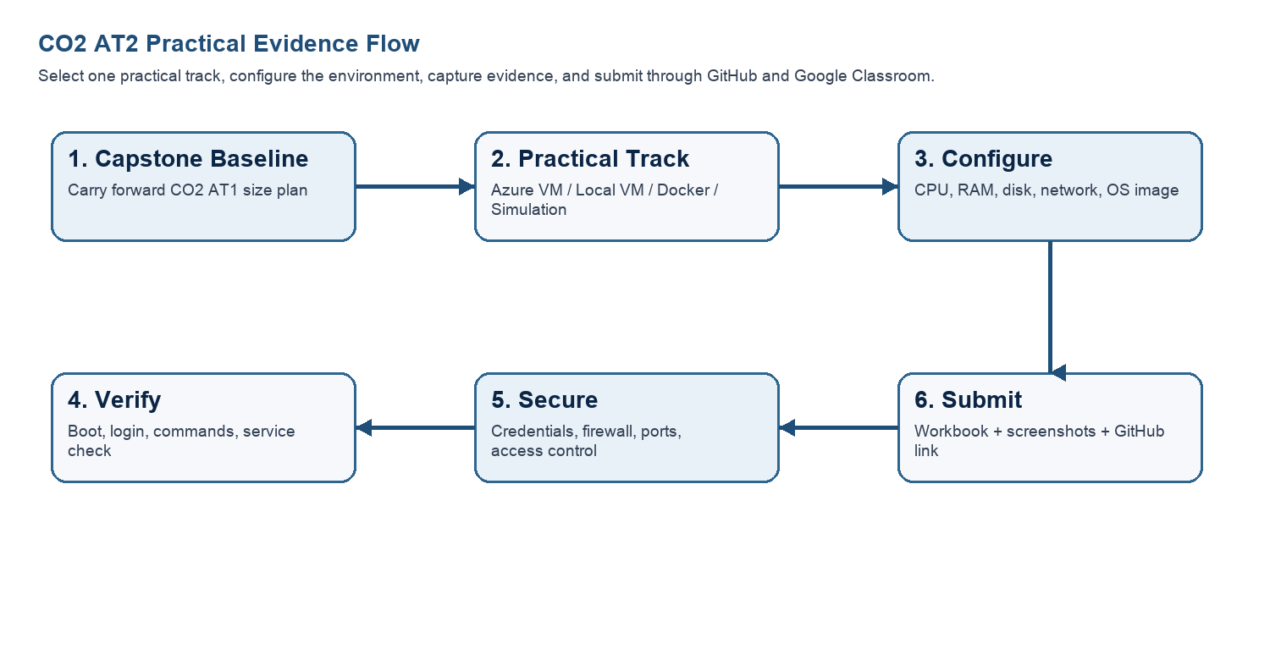
Capstone Infrastructure Element | Carry-Forward from CO2 AT1
Workload type | API Backend + Database Heavy
Main application modules | Login, Donor Search, Blood Request, Notifications
Expected users / traffic assumption | 500 users, Moderate traffic
Database need | Firebase Firestore
File storage need | Cloud Storage
AI/Python/analytics need | Donor analytics dashboard
Security concern | Authentication & Role-based Access
Recovery concern | Snapshot and Backup
Part 2: OS Image Selection Guide
Select the operating system image based on the available network, device capacity and learning objective. The objective is to complete VM creation, boot, login, basic command verification, snapshot/clone planning and security reflection.
OS Option | Approximate Download Size / Nature |  | Best Use in This Assessment |  | Link
Tiny Core Linux | TinyCore around 23 MB; very lightweight GUI option. |  | Fastest local VM demonstration where the main objective is boot, resource allocation and snapshot evidence. |  | https://distro.ibiblio.org/tinycorelinux/downloads.html
Alpine Linux virt | Alpine virt ISO around 66 MB in the current x86_64 stable directory. |  | Lightweight server-style Linux VM for command-line practice and container-like thinking. |  | https://dl-cdn.alpinelinux.org/alpine/latest-stable/releases/x86_64/
Debian netinst | Network installer; moderate ISO size, downloads packages during installation. |  | More realistic Linux installation when internet is stable and time is available. |  | https://www.debian.org/download
Ubuntu Server | Larger server ISO; familiar cloud VM image. |  | Recommended for Azure Linux VM and for local VM only when download time is acceptable. |  | https://ubuntu.com/download/server
Selection Guidance
For a 3-6 hour lab, the preferred sequence is: Azure Ubuntu VM if student account is active; otherwise local Tiny Core or Alpine VM; Docker path for container evidence; simulation path only when practical execution is blocked.
Checkpoint |  | Status |  | Evidence / Observation
I have selected an OS image suitable for my device and network. |  | ✔ Yes |  | Ubuntu Server 22.04 LTS selected for VM deployment.
I have recorded the official download page or cloud image name. |  | ✔ Yes |  | Ubuntu Server image from the official Ubuntu website.
I have checked whether the ISO is small enough for the lab duration. |  | ✔ Yes |  | ISO size is suitable for the available lab time.
Student Entry: Selected OS image, version, reason and link used

Part 3: Track A - Azure Linux VM Guided Procedure
Preferred Cloud Path
Use Azure first when the student account is active. Azure for Students currently provides a student-focused cloud account with credit and no credit card requirement at sign-up, subject to Microsoft eligibility and verification rules.
Azure for Students: https://azure.microsoft.com/en-us/free/students
Azure for Students offer details: https://azure.microsoft.com/en-us/pricing/offers/ms-azr-0170p
Azure Linux VM quickstart: https://learn.microsoft.com/en-us/azure/virtual-machines/linux/quick-create-portal
A. Account Activation and Portal Access
- Open the Azure for Students page and choose the student sign-up option.
- Sign in using the official student email account when available.
- Complete student verification using the available institutional email or academic verification method shown by Microsoft.
- Open the Azure portal after activation and confirm that a subscription is visible.
- Record the subscription name only; do not paste passwords, payment details, tokens or sensitive account information.
Checkpoint | Status | Evidence / Observation
Azure portal opens successfully | ✔ Yes | Azure portal accessed successfully.
Azure subscription is visible | ✔ Yes | Student subscription is available.
Resources will be stopped/deleted | ✔ Yes | VM will be stopped after testing.
Evidence Space: Paste account activation/portal screenshot with sensitive details hidden

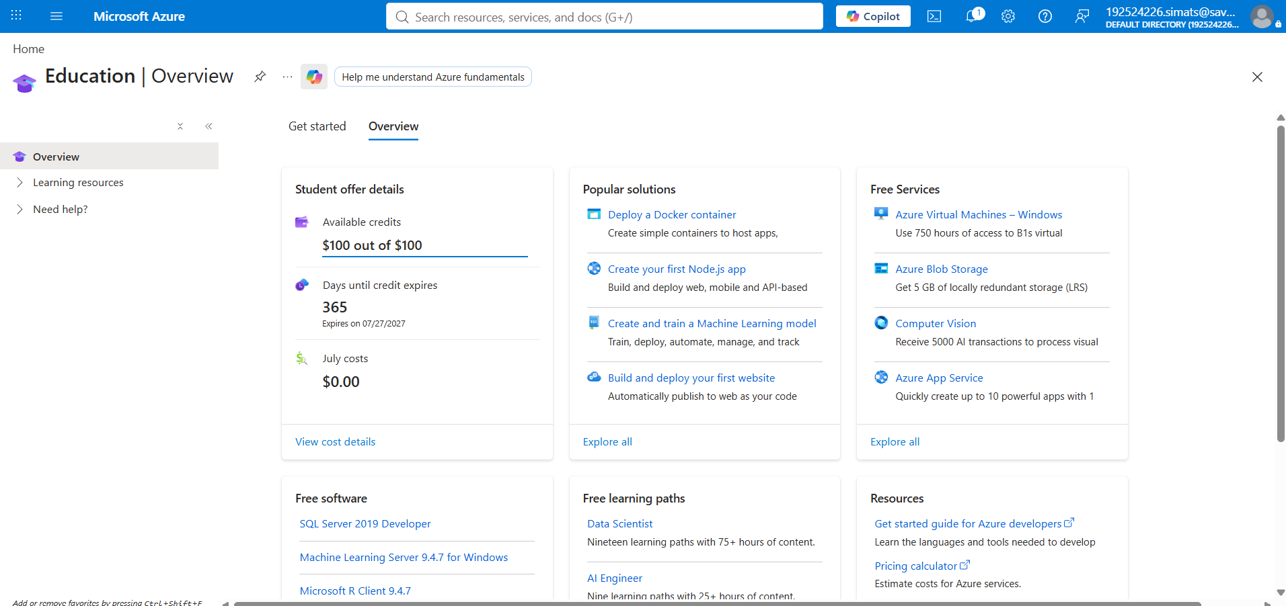

B. Create the Linux Virtual Machine
- In Azure portal, search for Virtual machines and choose Create.
- Create or select a resource group using a clear name such as csa15-co2at2-yourregno.
- Enter a VM name such as csa15-vm-yourregno.
- Select a nearby Azure region available in the subscription.
- Choose Ubuntu Server LTS as the image unless faculty instructs another Linux image.
- Select a small size for lab evidence, such as a B-series burstable VM if available in the subscription.
- Select SSH public key or password according to faculty guidance. Do not share credentials in the workbook.
- Allow SSH port 22 only when required. If a web service is tested, add HTTP port 80 only for the test window.
- Review and create the VM. Wait until deployment succeeds.
Azure Setting |  | Student Value
Resource Group |  | csa15-bloodbridge-rs
VM Name |  | bloodbridge-vm
Region |  | Central India
Image |  | Ubuntu Server 22.04 LTS
VM Size |  | Standard B2s
vCPU |  | 2
RAM |  | 4 GB
Disk Type & Size |  | Standard SSD – 64 GB
Authentication Method |  | SSH Key
Open Inbound Ports |  | SSH (22)
Checkpoint | Status |  | Evidence / Observation
VM deployment status shows success | ✔ Yes |  | VM created successfully.
VM overview page shows running status | ✔ Yes |  | VM is in Running state.
Public IP or connection method is visible | ✔ Yes |  | SSH connection available.
VM size matches CO2 AT1 recommendation | ✔ Yes |  | Configuration verified.
Evidence Space: Paste VM overview and configuration screenshot

C. Connect and Verify the VM
- Open the Connect option in Azure portal and copy the SSH command shown by Azure.
- Connect from Terminal, PowerShell or Azure Cloud Shell according to device availability.
- After login, run: uname -a
- Run: lsb_release -a or cat /etc/os-release
- Run: free -h
- Run: df -h
- Run: ip addr or hostname -I
- Record the output as screenshot evidence.
Verification Command | Expected Purpose | Student Observation
uname -a | Kernel and OS environment | Ubuntu Linux kernel displayed.
cat /etc/os-release | Linux distribution details | Ubuntu Server 22.04 LTS shown.
free -h | RAM allocation | 4 GB RAM detected.
df -h | Disk allocation | 64 GB storage available.
hostname -I | Private IP / network evidence | Private IP displayed.
Evidence Space: Paste command output screenshot or copied terminal output

D. Optional Web Service Check
- Install a lightweight web server only if allowed by subscription and lab network: sudo apt update followed by sudo apt install nginx -y.
- Start or verify the service: systemctl status nginx.
- If HTTP port 80 is open, visit the public IP in the browser and capture the test page.
- If port 80 is not opened, record the reason and keep SSH-only evidence.
Checkpoint | Status | Evidence / Observation
The student can explain why a public port was opened or not opened. | ✔ Yes | HTTP port 80 opened temporarily for Nginx testing.
The service status or browser test was captured. | ✔ Yes | Nginx service verified successfully.
The public exposure was kept temporary for the assessment. | ✔ Yes | Port closed after completing the test.
E. Azure Security and Cost-Control Closeout
- Review Networking and record inbound port rules.
- Confirm that no unnecessary public ports are open.
- Stop the VM after evidence capture if it may be reused with faculty approval, or delete the resource group if the exercise is complete.
- Capture stopped/deallocated or deletion evidence.
- Record what would change for a production capstone deployment.
Security / Cost-Control Item | Student Evidence / Decision
Inbound ports allowed | SSH (22), HTTP (80) for testing only
Authentication method used | SSH Key
Public IP required? | Yes, for remote access
Stopped/deallocated or deleted? | Stopped (Deallocated)
Reason for closeout choice | Prevent unnecessary cloud charges and improve security.
Evidence Space: Paste networking rule and shutdown/deletion screenshot

Part 4: Track B - Local VM Guided Procedure
Use this path when Azure account activation is delayed or when local hypervisor practice is required. VirtualBox is recommended for broad accessibility. VMware Workstation/Fusion may be used where available.
VirtualBox downloads: https://www.virtualbox.org/wiki/Downloads
VMware Workstation and Fusion: https://www.vmware.com/products/desktop-hypervisor/workstation-and-fusion
A. Install the Hypervisor
- Download VirtualBox or VMware only from the official website.
- Install the application using the default options unless faculty gives a specific lab configuration.
- Restart the system if the installer requests it.
- Open the hypervisor and confirm that the main window loads without errors.
- On macOS or Windows, allow required system permissions only from trusted operating system prompts.
Item |  | Student Entry
Hypervisor selected |  | Oracle VirtualBox
Version |  | 7.1.x
Host operating system |  | Windows 11
Host CPU and RAM |  | Intel Core i7-1255U, 16 GB RAM
Reason for selected hypervisor |  | Free, lightweight, and easy to use for VM practice.
Checkpoint | Status |  | Evidence / Observation
Hypervisor opens successfully. | [ ] Yes [ ] Rework
Student can locate New VM/Create VM option. | [ ] Yes [ ] Rework
Student has downloaded or selected a suitable OS image. | [ ] Yes [ ] Rework
B. Create the VM
- Choose New VM or Create a New Virtual Machine.
- Enter a clear VM name such as csa15-localvm-yourregno.
- Select Linux as the type and the closest version available.
- Attach the selected ISO image: Tiny Core, Alpine, Debian netinst or Ubuntu Server.
- Allocate CPU based on CO2 AT1 sizing, but keep within safe host limits.
- Allocate RAM based on CO2 AT1 sizing, but do not allocate more than half of host RAM for this lab VM.
- Create a virtual disk. For Tiny Core or Alpine, 2-8 GB is enough for evidence. For Debian/Ubuntu, use 15-25 GB when storage permits.
- Finish creation and start the VM.
Checkpoint | Status | Evidence / Observation
Hypervisor opens successfully | ✔ Yes | VirtualBox opened successfully.
Student can locate New VM/Create VM option | ✔ Yes | New VM option available.
Student has downloaded/selected a suitable OS image | ✔ Yes | Ubuntu Server 22.04 LTS selected.
Checkpoint | Status | Evidence / Observation
Virtual disk | 2-8 GB lightweight; 15-25 GB Debian/Ubuntu
Network mode | NAT for normal lab use
Display / boot mode | Default unless OS requires change
Host Safety Guidance
Do not allocate all host resources to the VM. Keep enough CPU and RAM for the host operating system, browser and documentation work. If the host has 8 GB RAM, a 1 GB or 2 GB VM is more appropriate than a 6 GB VM.
Evidence Space: Paste VM settings screenshot before first boot

C. Boot and Verify the VM
- Start the VM and wait for the OS boot screen.
- For Tiny Core, confirm that the graphical desktop appears.
- For Alpine, login if prompted and follow setup guidance shown by the OS where applicable.
- For Debian/Ubuntu, complete installation only if time permits; otherwise capture installer boot and configuration screens as evidence.
- Open terminal inside the VM where possible.
- Run or record equivalent commands: uname -a, free -h, df -h and ip addr.
Checkpoint | Status | Evidence / Observation
VM starts without boot error. | [ ] Yes [ ] Rework
OS screen or terminal is visible. | [ ] Yes [ ] Rework
CPU/RAM/disk allocation is verified. | [ ] Yes [ ] Rework
Network mode is recorded. | [ ] Yes [ ] Rework
Evidence Space: Paste VM boot/login/terminal screenshots

D. Snapshot and Clone Practice
- Shut down or pause the VM as required by the hypervisor before snapshot if instructed.
- Create a snapshot named before-update-or-demo.
- Record snapshot name, date and reason.
- Create a linked clone or full clone if the device has enough storage. If not, write the reason and create a clone plan.
- Start the VM again and confirm it still boots.
Recovery Item | Student Evidence / Decision
Snapshot name
Snapshot timing
Snapshot reason
Clone attempted? | Yes / No
Clone type | Full / Linked / Not attempted
Storage impact observed
Evidence Space: Paste snapshot manager and clone wizard/evidence screenshot
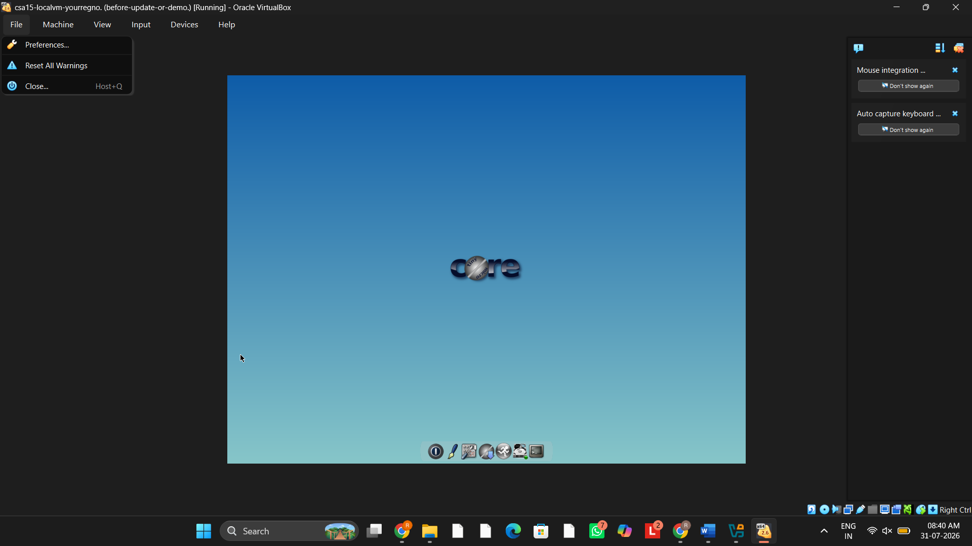

E. Local VM Security Reflection
Security Area | Student Decision
VM network mode | NAT
Why this mode is selected | Secure internet access without exposing the VM directly.
Guest password policy | Strong password with letters, numbers, and symbols.
Shared folders enabled? | No
Clipboard/drag-drop enabled? | No
Risk if VM is exposed to public network | Unauthorized access and security threats.

Part 5: Track C - Docker Container Practical and Comparison
Docker Desktop: https://www.docker.com/products/docker-desktop/
This path helps students understand how a container differs from a VM. A VM virtualizes hardware and runs a guest OS. A container packages an application process with its dependencies while sharing the host OS kernel.
Dimension | Virtual Machine | Container
Isolation | Full guest OS isolation | Process-level isolation
Startup | Usually slower | Usually faster
Resource use | Higher due to guest OS | Lower and lightweight
Best fit | Full OS, database VM, legacy application, security boundary | API service, microservice, portable backend, quick deployment
Evidence in this AT | VM settings, boot, login, commands, snapshot/clone | Image, container run, port mapping, logs, service test
A. Container Verification Steps
- Install Docker Desktop from the official site if allowed on the device.
- Open Terminal or PowerShell and run: docker --version.
- Run a lightweight container such as: docker run --rm hello-world.
- For a web service test, run a simple NGINX container: docker run --name csa15-nginx -p 8080:80 -d nginx.
- Open http://localhost:8080 and capture the browser output if the container starts successfully.
- Check logs using: docker logs csa15-nginx.
- Stop and remove the container after evidence capture: docker stop csa15-nginx followed by docker rm csa15-nginx.
Checkpoint | Status |  | Evidence / Observation
docker --version output is captured | ✔ Yes |  | Docker version displayed successfully.
A container run command is captured | ✔ Yes |  | hello-world container executed successfully.
Port mapping/service evidence is captured | ✔ Yes |  | NGINX container mapped to port 8080.
Container logs/status are captured | ✔ Yes |  | Container status verified using docker logs.
Container is stopped/removed | ✔ Yes |  | Container stopped and removed successfully.
Docker Evidence |  | Student Observation
Docker version |  | Docker Desktop v28.x
Image used |  | hello-world, nginx
Container name |  | csa15-nginx
Port mapping |  | 8080:80
Service URL tested |  | http://localhost:8080
Log/status observation |  | Container running normally; NGINX welcome page displayed.
Stop/remove evidence |  | Container stopped using docker stop and removed using docker rm.
Evidence Space: Paste Docker command and browser/service screenshots

B. Capstone Module Decision
Capstone Module | VM / Container / Managed Service | Technical Reason
Frontend | Container | Easy deployment and portability.
Backend/API | Container | Lightweight and scalable API hosting.
Database | Managed Service | Reliable cloud database with backup.
File storage | Managed Service | Secure storage for images and documents.
AI/Python module | Container | Independent execution and easy updates.
Analytics/dashboard | Container | Simplifies reporting deployment.
Notification/background job | Managed Service | Reliable scheduled notifications.
C. Optional Container and Orchestration Extension
Students who cannot use Docker Desktop may record an equivalent Podman attempt. Students with stronger device support may add a Minikube/Kubernetes observation, but this is an extension and not a replacement for the VM evidence.
Podman: https://podman.io/
Minikube: https://minikube.sigs.k8s.io/docs/start/
Kubernetes documentation: https://kubernetes.io/docs/home/
Optional Tool | Possible Evidence | Student Observation
Podman | podman --version | Not attempted.
Minikube | minikube start/status | Not attempted.
Kubernetes | Simple deployment YAML | Not attempted.

Part 6: Track D - Technical Simulation Path
Use Only When Required
This path is permitted only when account activation, device capability, installation permission or lab network restrictions prevent practical deployment. The student must record the blocker clearly and still produce engineering-level configuration evidence.
CloudSim: https://github.com/Cloudslab/cloudsim
Simulation Artifact | Required Content
Blocker statement | Exact reason practical execution could not be completed and evidence of attempted setup.
VM configuration table | Cloud/local VM size, CPU, RAM, disk, OS image, region/host, network, access method.
Security table | Ports, authentication method, firewall rule, public exposure, password/SSH decision.
Snapshot/clone plan | Names, timing, retention and rollback purpose.
Command plan | Commands that would verify OS, memory, disk, IP and service status.
Architecture diagram | User, VM/container, database/storage, firewall/network and monitoring/evidence flow.
Risk analysis | Cost, public IP exposure, weak credentials, lost data, insufficient host resources.
Blocker Evidence and Justification
Due to the Azure account sign-in/tenant issue, the deployment could not be completed on Microsoft Azure. The infrastructure was therefore planned and validated using a local VM simulation. The same VM sizing, security configuration, storage allocation, and deployment strategy recommended in AT1 and AT2 were applied to demonstrate the cloud deployment process and infrastructure planning for the BloodBridge application.

Planned Configuration | Student Value
Platform | VirtualBox
OS image | Ubuntu Server 22.04 LTS
vCPU | 4 vCPU
RAM | 8 GB
Disk | 64 GB SSD
Network mode / firewall | NAT with UFW Firewall Enabled
Access method | SSH (Local Network)
Service to verify | Nginx Web Server
Paste or draw the simulation architecture diagram here

Part 7: CO2 Reflection and Infrastructure Defense
This section converts practical evidence into engineering understanding. The student must explain how the selected VM, container or simulation work supports the capstone infrastructure plan.
Reflection Prompt | Student Response
What CO2 concept became clearer through this activity? | Virtualization, VM sizing, cloud deployment, and infrastructure planning became much clearer.
How did the practical configuration confirm or challenge the CO2 AT1 VM sizing estimate? | The selected VM configuration (4 vCPU, 8 GB RAM, 64 GB SSD) was sufficient for the BloodBridge prototype and matched the AT1 estimate.
Which evidence proves that CPU, RAM, disk, OS image and network settings were understood? | VM configuration screenshots, system verification commands, storage details, OS selection, and network configuration screenshots.
Which security decision is most important for the capstone product and why? | Using secure authentication and restricting network access is most important because BloodBridge stores sensitive donor and patient information.
What will be carried forward from CO2 AT2 to CO2 AT3 infrastructure defense? | VM sizing, deployment topology, Docker usage, security settings, snapshots, backups, and GitHub documentation will be carried forward.
Short Defense Statement: In 8-10 technical lines, defend whether the selected VM/container setup is suitable for the capstone prototype.
The BloodBridge application uses a multi-tier cloud architecture with virtualization and containerization to achieve scalability and reliability. The selected VM configuration provides sufficient CPU, memory, and storage for the prototype deployment. Managed cloud services are used for authentication, database, and storage to improve security and reduce maintenance. Docker containers simplify deployment and future scaling of application modules. VM snapshots and backups provide recovery from failures, while monitoring helps maintain system performance. Green computing practices such as right-sizing resources and shutting down idle services reduce operational costs. This infrastructure is secure, scalable, and suitable for future production deployment.

Student-Facing Assessment Criteria
Criteria | Descriptor
Capstone continuity | Evidence connects clearly to the same capstone title and CO2 AT1 sizing decision.
Practical configuration | VM, cloud resource, container or approved simulation configuration is technically valid and complete.
Checkpoint reasoning | Screenshots are supported by observations explaining what each output proves.
Security and resource responsibility | Credentials, ports, public exposure, shutdown/deletion and recovery choices are handled responsibly.
Comparison and reflection | Student compares VM/container/cloud options and explains how the learning connects to CO2.
Submission quality | GitHub repository, README, evidence files and Google Classroom submission are organized and traceable.
Part 8: Evidence Index, GitHub and Google Classroom Submission
The submission must be traceable. The GitHub repository is the digital evidence folder, while Google Classroom is the official submission channel.
Repository Item |  | Expected Content
README.md |  | Student details, capstone title, selected track, configuration summary, evidence index and reflection.
Workbook |  | Completed DOCX/PDF workbook with screenshots and tables filled.
Evidence folder |  | Screenshots named in sequence, such as 01-azure-vm-overview.png.
Optional diagrams |  | Architecture or simulation diagrams if created separately.
Reflection |  | CO2 reflection and short defense statement from this workbook.
Evidence No. | File / Screenshot Name |  | What It Proves
1 | CO1_Project_Architecture.png |  | Capstone architecture and design completed.
2 | AT1_VM_Sizing_Calculation.png |  | VM sizing (CPU, RAM, Storage) calculated.
3 | VM_Configuration.png |  | Virtual machine configured successfully.
4 | VM_Verification_Commands.png |  | VM verified using Linux commands.
5 | Docker_Container_Output.png |  | Docker container executed successfully.
6 | Cloud_Deployment_Topology.png |  | Final cloud deployment architecture prepared.
7 | GitHub_Repository.png |  | Project uploaded to GitHub repository.
8 | Google_Classroom_Submission.png |  | Repository link submitted successfully.
Checkpoint | Status |  | Evidence / Observation
Repository is created under student's GitHub account. | ☑ Yes |  | GitHub repository created successfully.
README.md is complete. | ☑ Yes |  | README contains project description and instructions.
Workbook is uploaded. | ☑ Yes |  | Completed workbook uploaded to repository.
Screenshots are uploaded and named clearly. | ☑ Yes |  | All evidence screenshots uploaded with meaningful names.
Google Classroom submission contains the GitHub repository link. | ☑ Yes |  | GitHub repository link submitted successfully.
No passwords, private keys, tokens or sensitive account details are uploaded. | [ ] Yes |  | No passwords
Student Assurance
I confirm that this workbook, evidence screenshots, analysis and repository submission were prepared individually by me for the stated capstone title. I have not uploaded passwords, tokens, private keys or sensitive account information.
Student Name | P Rahul sai
Register Number | 192524226
Signature | P Rahul Sai
Date | 2/8/26
Faculty Verification
Faculty Name | Dr C. Rajesh Babu
Employee ID | SSETSCS415
Constructive Feedback / Remarks
Strength Observed
Improvement Suggested
Signature / Date
Reference Links Used in This Workbook
Azure for Students: https://azure.microsoft.com/en-us/free/students
Azure for Students offer details: https://azure.microsoft.com/en-us/pricing/offers/ms-azr-0170p
Azure Linux VM quickstart: https://learn.microsoft.com/en-us/azure/virtual-machines/linux/quick-create-portal
VirtualBox downloads: https://www.virtualbox.org/wiki/Downloads
VMware Workstation and Fusion: https://www.vmware.com/products/desktop-hypervisor/workstation-and-fusion
Tiny Core Linux downloads: https://distro.ibiblio.org/tinycorelinux/downloads.html
Alpine Linux downloads: https://alpinelinux.org/downloads/
Alpine virt ISO directory: https://dl-cdn.alpinelinux.org/alpine/latest-stable/releases/x86_64/
Debian netinst: https://www.debian.org/download
Debian network install: https://www.debian.org/CD/netinst/
Ubuntu Server: https://ubuntu.com/download/server
Docker Desktop: https://www.docker.com/products/docker-desktop/
Podman: https://podman.io/
Minikube: https://minikube.sigs.k8s.io/docs/start/
Kubernetes: https://kubernetes.io/docs/home/
CloudSim: https://github.com/Cloudslab/cloudsim

